Lauderdale Profiles

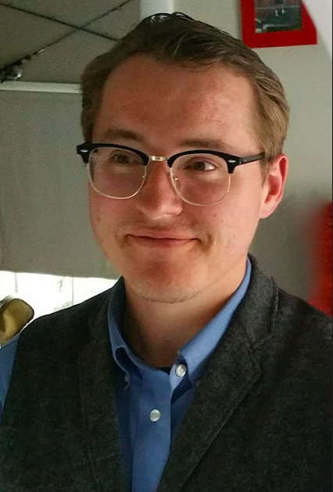
Russell Brandon RHS ‘05
Teacher Mississippi State University
Bachelor of Arts in Psychology, Master of Arts in Cognitive Science
Christian Brothers University, University of Memphis, Arizona State University

Q: How did you select your college major, certification program, or career path?
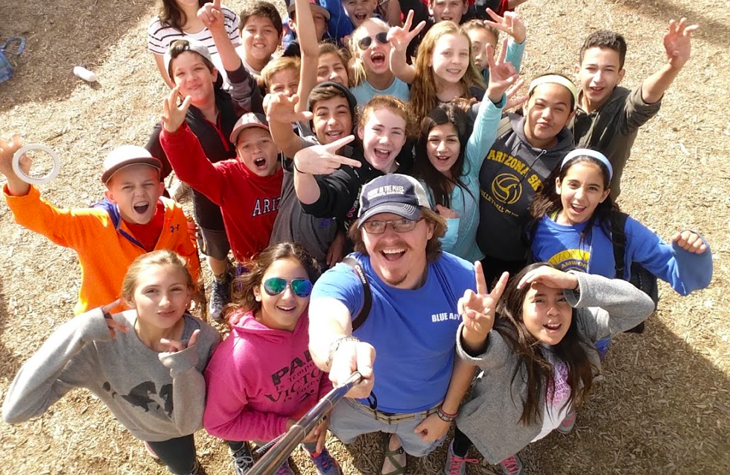
A: I picked Psychology as my major because I enjoyed learning and I wanted to know how people learn! I read a few books in high school that discussed how we could use things like statistics and modeling to see how much people know, and then help them know more by designing lessons and activities. After learning more about psychology in college, I decided that Cognitive Psychology was one of the best ways I could study learning and comprehension. I went to graduate school and got to design experiments using learning games as well as lessons used in classrooms, and that’s when I decided that I wanted to be the one using those lessons in the classroom! After I finished my Masters in Cognitive Science, I started a job at St. Francis Xavier Elementary School teaching computer science and managing technology. After three years of teaching and managing, I decided to go back to school to get a certification to teach Physics and am teaching psychology to students at Mississippi State.

Q: What was the biggest influence in your selection of career path?
A: My biggest influence was probably the amount of time my parents gave me to explore. They always supported me asking questions and finding answers, and that helped me find people throughout my life who prioritize adventure.

Q: If you could go back to high school and select any elective course to take that would have better prepared you for college/career, what would it be?
A: I would try to take more classes in another language, or try to find a class about economics and money management.

Q: What is your favorite aspect of your job?
A: I get to teach! I love creating experiences for people to learn, and I love seeing someone start to “get it” when I’ve introduced a new concept.

Q: How do you/your company make a positive impact on society/our community?
A: Learning! Helping people become better learners is paramount in a world that’s constantly discovering new things.

Q: What’s the most interesting thing you have been able to do in your professional career?
A: As weird as it sounds, teaching Preschoolers about computers has probably been the most interesting thing for me. Seeing someone who can barely put together a sentence tell you about how they did something cool on a keyboard or how they learned something new is pretty awesome.

Q: What makes you get up each morning excited about your profession?
A: Conversation! I’m always the happiest when I’ve had an awesome conversation with a student, and I love getting asked questions that I have to research so I can bring back an interesting answer or more questions.

Q: What advice would you share with K-12 students who are considering your profession?
A: Start talking to your teachers about teaching! There are lots of things that go into creating a learning space, and it’s really cool to see behind the scenes. I always got to see the cool things my mom was doing as a teacher, but not everyone has that opportunity, so start talking to your teachers now!

Q: What were some of the jobs you held as a young person (summer jobs, part time work, etc.), before you were on your career path? Did they play any part in your future occupation?
A: I worked at a snow cone hut. That was cold. I worked at a restaurant for a couple summers, and I think that helped me develop an amount of patience with people. Lots of the work I did with the Boy Scouts helped me develop a sense of service and care for others.

Q: What are your plans for the future?
A: I’ve got a ways to go, but I’d really like to be part of starting a school that’s project-based. Imagine a school where every class is a different profession, and you get to learn about it and do some of the things that people in that job get to do. Yeah, something like that!

